<https://github.com/boboppie/coursera-course-statistics_one>

**LECTURE 13–**

**Segment 1: Student’s t-test**

* Compare 2 means

z = (observed-expected)/SE (if we know the population parameters (mean, SD), it is not usual)

**t = (observed-expected)/SE** (if we don’t know population parameters (mean, SD))

1.- z-test: (if we know the population parameters (mean, SD), it is not usual)

2. Single sample t t-test: (if we don’t know population parameters (mean, SD))

3.- Dependent samples t: (evaluating difference between two related samples)

4. Independent samples t: (evaluating difference between two independent samples)

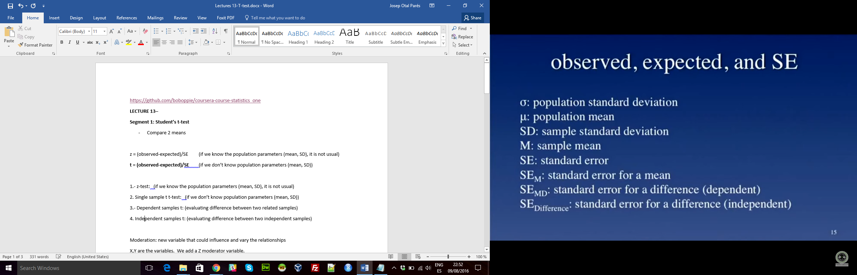

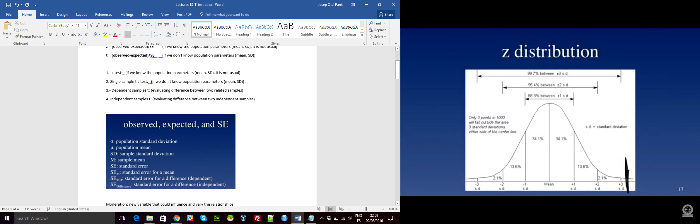

* This z-distribution varies depending on the size,
  + Small sample size 🡪 z distribution comes flatter
  + Reaching around 100 observations, it converges to the distribution

Single sample t

* t =(M -µ)/SE
* SE2M = SD2/N 🡪 SEM = SD/ √N
* SD2 = E(X-M)2 /(N -1) = SS/df =MS df: degrees of freedom
* Effect size (cohen’s d): removes the bias due to the size
  + - Higher than 1 is a large effect size **d =(M -µ)/SD**

**Segment 2: Dependent and independent t-test**

D : difference D = (X1 – X2)

Independent:

* SD2POOLED = df1/dfT (SD12) + df2/dfT (SD22)
* SE2M1 = SD2POOLED/N1
* SE2M2 = SD2POOLED/N2
* SE2Difference = SE2M1 + SE2M2